Labs: Threats, Attacks, and Vulnerabilities
Kyle M. Stecki
University of Advancing Technology

2019/11/02 - 11:27
Lab 1: Vulnerabilites part 1
practicing footprinting, spoofing, and DoS attack strategies
Using Kali machine to use nmap
Did a scan on 192.168.27.0/24
Saved file to hosts.txt
Performed a syn scan using nmap on the same ip
Using leafpad to view the results of the scan in host.txt
Now using Zenmap to perform similiar tasks
performed a scan on kali box using zenmap on 192.168.27.18 and used wireshark on win 10 box to capture the data
Performed another scan in zenmap on 192.168.27.0/24
Using win 10 machine to learn about wireshark
using wireshark to view the packets from a previously saved snapshot
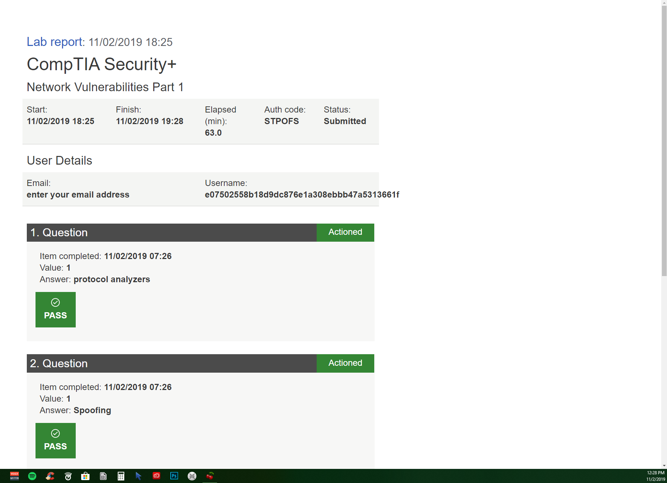
2019/11/03 - 21:10
Lab 2: vulnerabilites part 2
Using wireshark to scan tcp port 80
On the server instance i am going through the settings
deleted browser history
Using the kali machince to ping an ip
observing the pings in wireshark on the windows machine
Now moving on to the anti-phising toolbar
installing firefox on the win10 machine
downloading the netcraft toolbar for firefox
checking for phishing websites
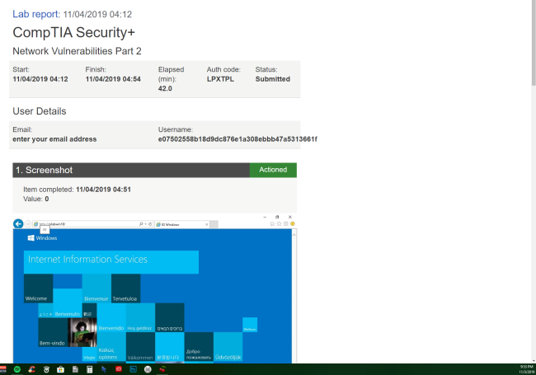

2019/11/03 - 21:55
Lab 3: Firewall Rule Based Management
Using one of the server machines to ping the win 10 machine
went into the firewall settings for win10 machine
changed the firewall rule for file and printer sharing and turned on the firewall
tried ping again from server machine and it did not go through as expected
Swtiched back the firewall rule on the win10 machine and pinged from the server and it worked again
performing the ping actions in reverse
Performing a remote desktop connection from the win10 machine
used RDP to change the firewall rule on the server from the win10 machine
pinged the server and got no response
reversed the process to turn the friewall rule back on
Using the server machine to change more firewall rules
used the CLI to set all the firewall rules to the off state
pinged from the win10 machine to the server and got a reply
Used the CLI to turn back on all firewall rules
pinged again from win10 machine with no reply
